Coventry University

School of Computing, Engineering and Mathematics

**Report on the user experience design of the website**

**Student Name:** Wong Pak Kwan

**Student ID:** 247030520

VT6012CEM User Experience Design

**1 April 2025**

Content

1 Introduction 3

2 The scope and the goals of the redesign 4

2.1 The scope of the design 4

2.2 The goals of the design 8

3 Persona 9

4 Prototype 10

4.1 Screen description and Screen flow 10

4.2 Prototype link 18

4.3 Demonstration 19

# 1 Introduction

Buymore.hk is an online platform specializing in computer hardware, offering a wide variety of computer hardware to meet the needs of users. From processors, graphics cards to whole computers. It even includes peripheral equipment and accessories such as live broadcast products, business software, printers, scanners, etc. At the same time, the website provides a variety of payment methods and ordering methods. Also, websites provide network configuration, cabling engineering, backup solutions, data recovery and other services. Both the service and product diversity are very good. So, the website provides a convenient shopping experience for users looking to upgrade or build their own computer.

Webpage Link: <http://buymore.hk>

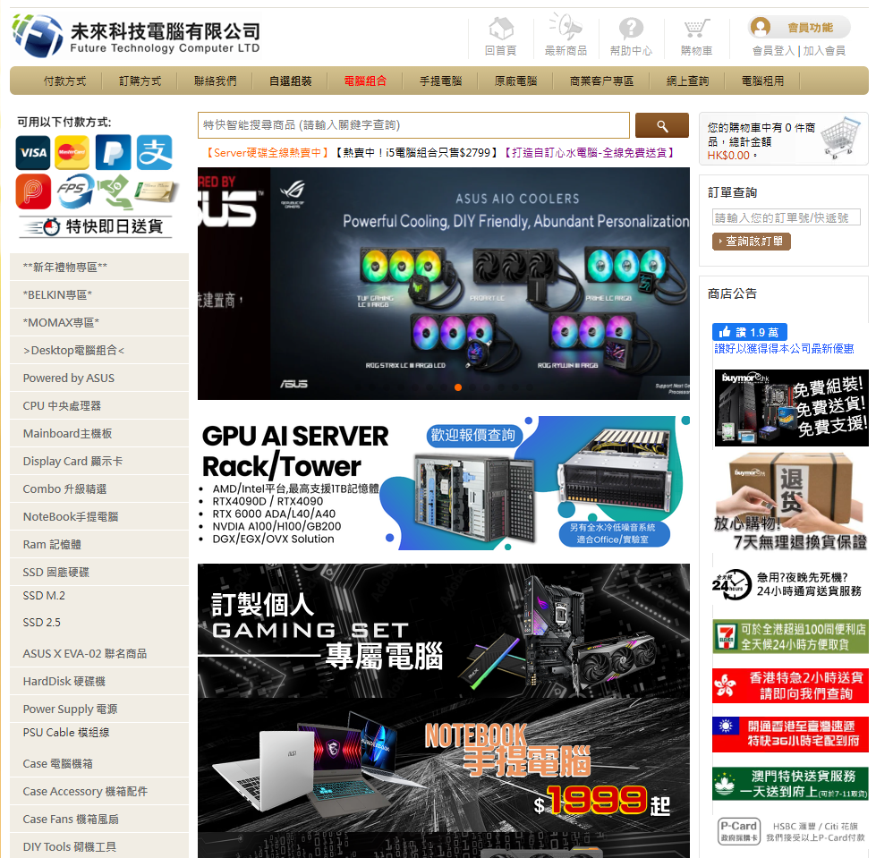

# 2 The scope and the goals of the redesign

# 2.1 The scope of the design

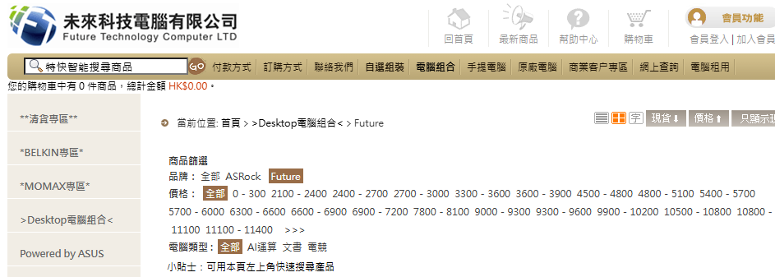

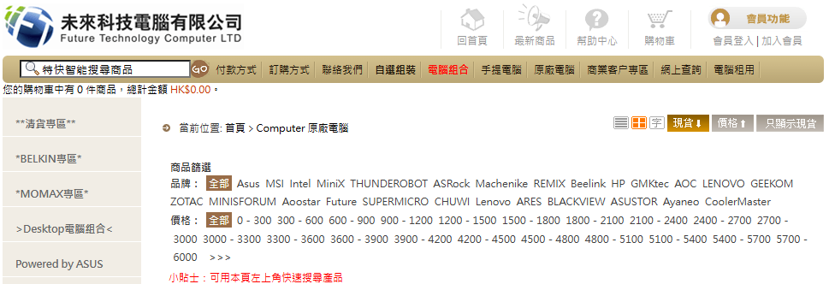

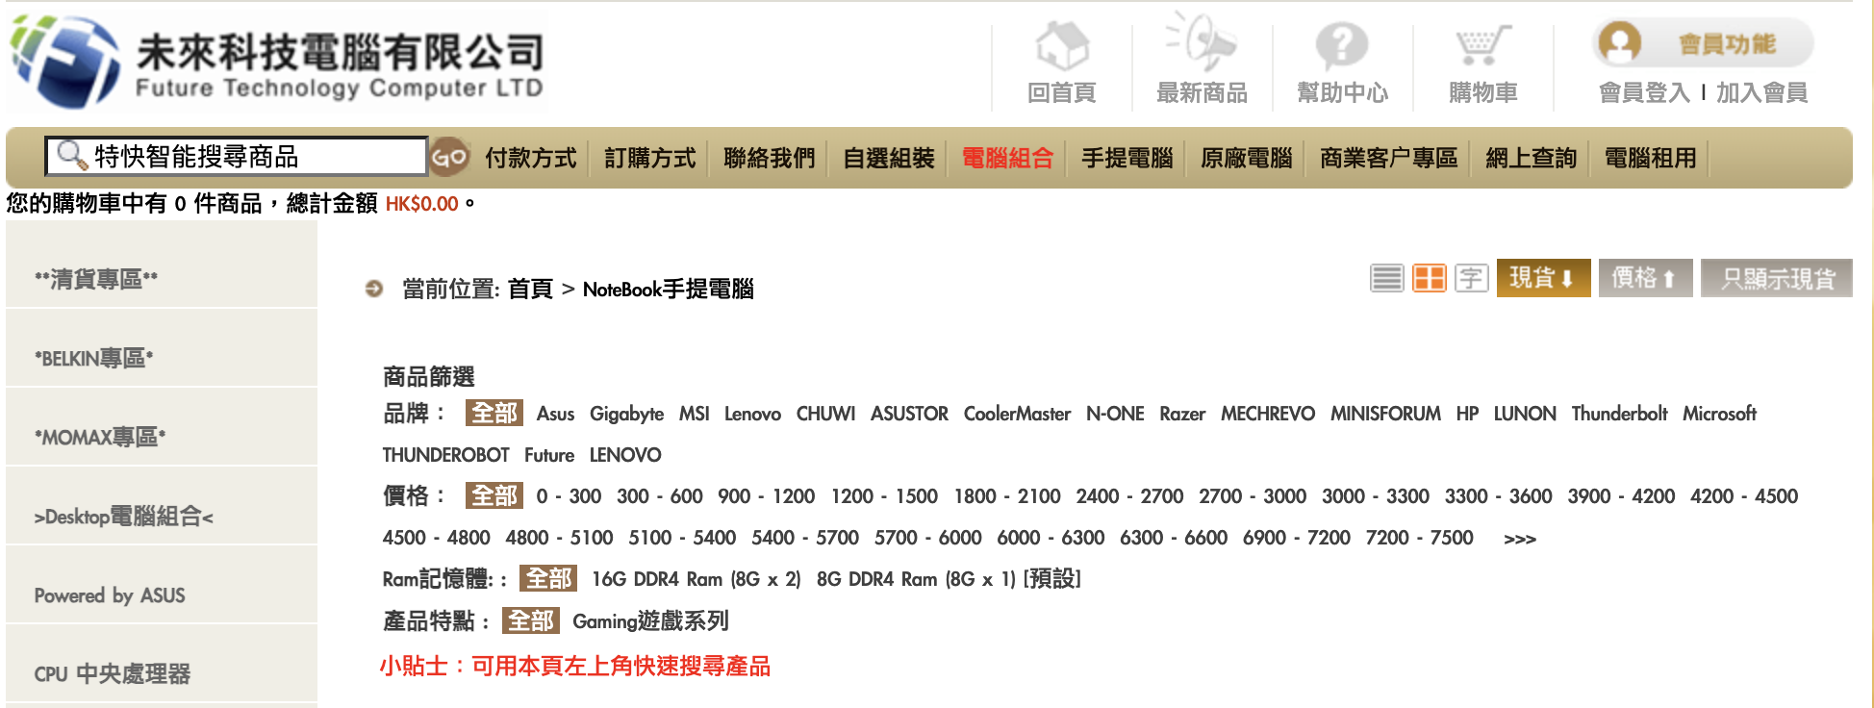

The price section and having some filter button of the Desktop Computer combination page, laptop page and original computer page. The User can filter and purchase the hardware product.

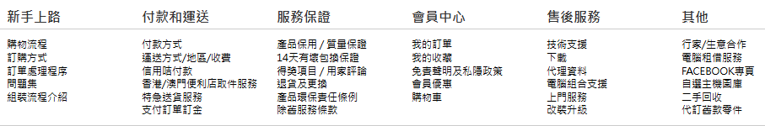

This part is on the bottom of any page. The User can click on the text to get the information or survey.

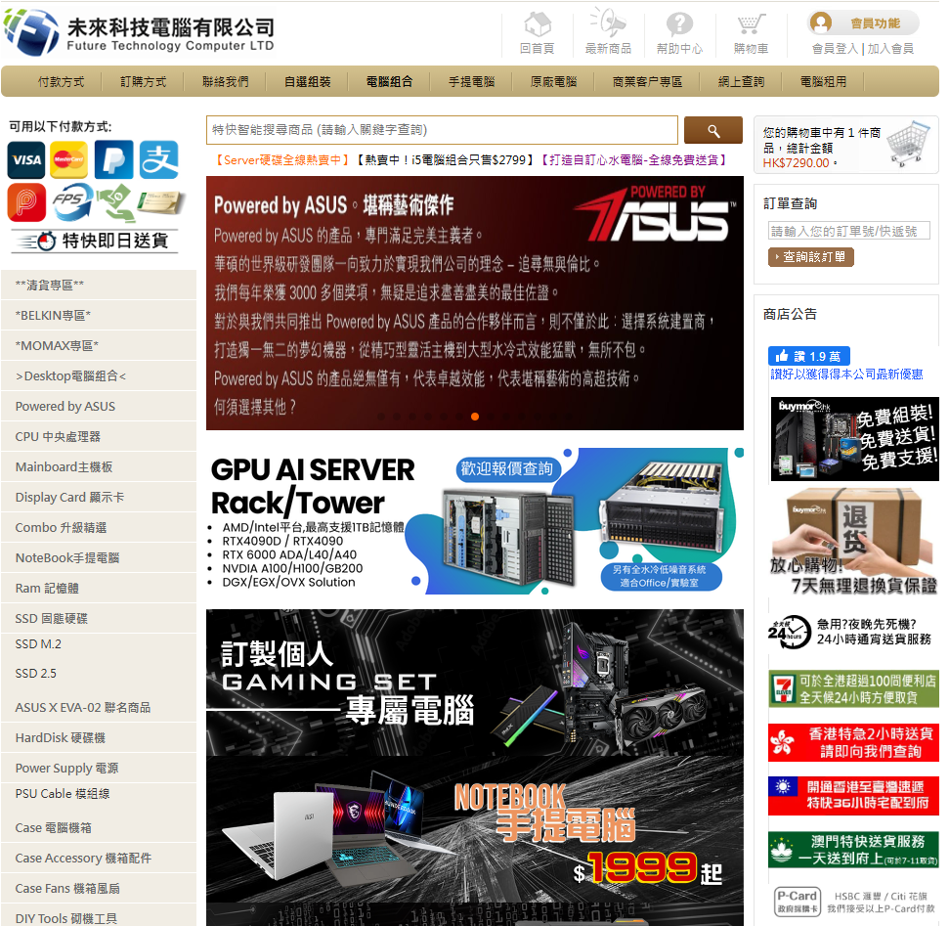

In the home page, the top of the bar. Users can click the button to complete the work.

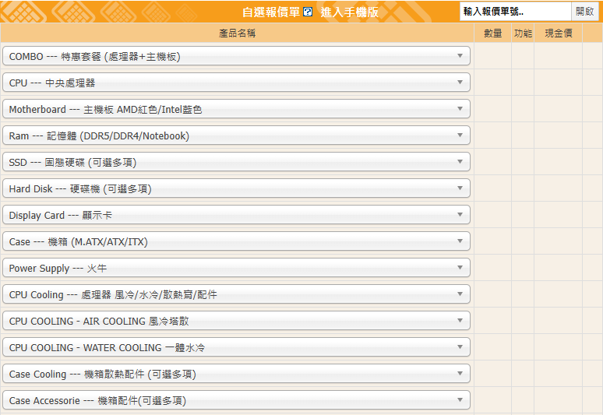

The drop-down menu in the self-selected quotation form. That makes the user choose the hardware combined. This part on the DIY(自選組裝) page

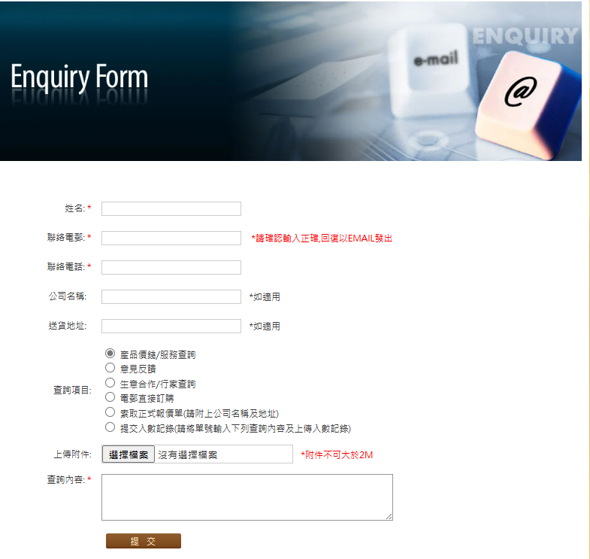

This part is on the online enquiry page, the customer can provide and submit feedback or questions to customer service.

# 2.2 The goals of the design

**Improve the “Efficient” of the buymore.hk website:**

The new design aims to facilitate easier interaction of the user with the site. Some of these will be the simplification of navigation so that the customer can find the product or service needed with less effort and the removal of unnecessary steps. Better filtering options, logical structure, and responsive design will make the search, comparison, and purchase less time consuming and less stressful.

**Enhance the “Utility and flexible” of the buymore.hk website:**

Utility is important to provide practical value or produce to users. Therefore, it should update unclear product descriptions or buttons. Products have more details and illustrations. So, customers would purchase what they want. Also, the website should increase more error control or reset control. So, users have flexible control.

**Improve the “Learnable” of the buymore.hk website:**

The interface is designed for simplicity of learning and usage for even the most inexperienced visitors. Tools like tutorials, a prominent "Getting Started" location, and easy-to-understand icons allow for better user understanding. The aim is to minimize the learning process as much as possible so users will be comfortable enough to navigate and make the most of the site for their services and shopping.

**Easy to Remember the buymore.hk website:**

Create a user-friendly and consistent interface with easy-to-remember usage of the site on future visits. Properly positioned buttons, common menu formats, and unique visual notifications make the user confident with the site even after some time has elapsed.

# 3 Persona

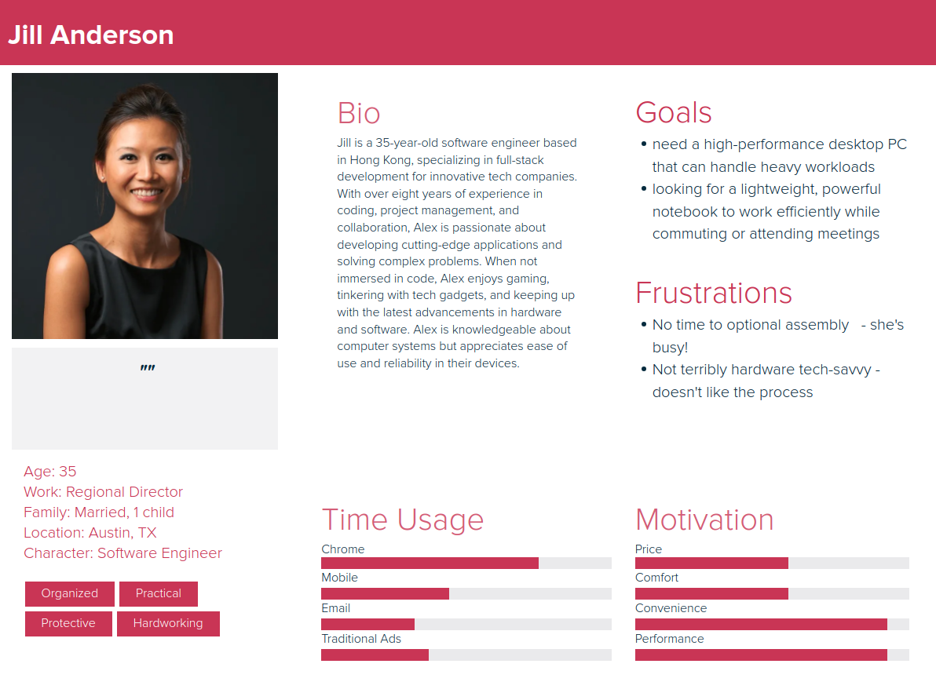

# 4 Prototype

# 4.1 Screen description and Screen flow

**Original Design**



**After Redesign**

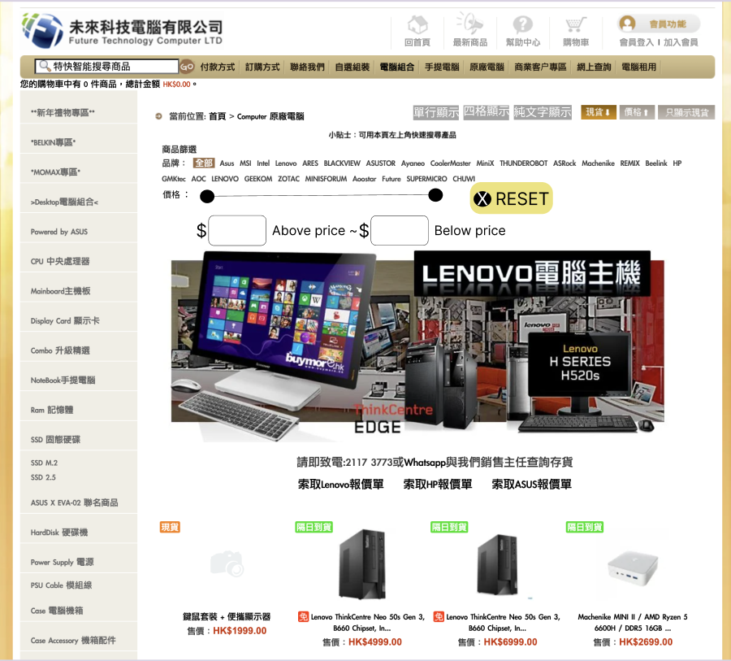

This screen is the screen for the user to purchase the whole computer. Comparison between old and new designs, the old design categorizing methods linking subpages in the same category are repetitive, such as listing the pricing ranges by every 300 intervals from 0 to 6000 until the “>>>” button. The “>>>” button means filtering above 6000 price. But the user may not know the button's meaning since it does not have a good illustration. Some unmeaningful icon buttons on the top right are doing different display methods. After redesigning, it can see the button of each range 300 price is changed to enter the price. Having rolling bars to control or select the above price and below price. That improves product filtering efficiency. Having the reset button. The user is more comfortable filtering the price again. Also put the tips on the top and center. So, the user would easily find the search function position. On the other hand, changing the unmeaningful icon buttons to text buttons. Users would be more aware of the function. Also, using text buttons in order to maintain consistency and aesthetics.

**Original Design**



**After Redesign**

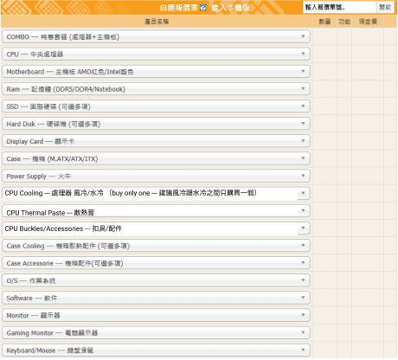

This screen is the screen for the user to purchase the computer Component such as CPU, ram, display card. Comparison between old and new designs, the old design has a lot of CPU Cooling dropdown menu and too many components in one dropdown menu. It may make users confused, and it is hard to find out what they want. Therefore, after redesigning, it can see the component is separated into three parts. They are CPU Cooling, CPU Thermal Paste and CPU Buckles/Accessories. The user would be quicker to find out what they want. Also reminding users to buy one CPU cooling between air cooling and water cooling to prevent customers buying more.

**Original Design**



**After Redesign**

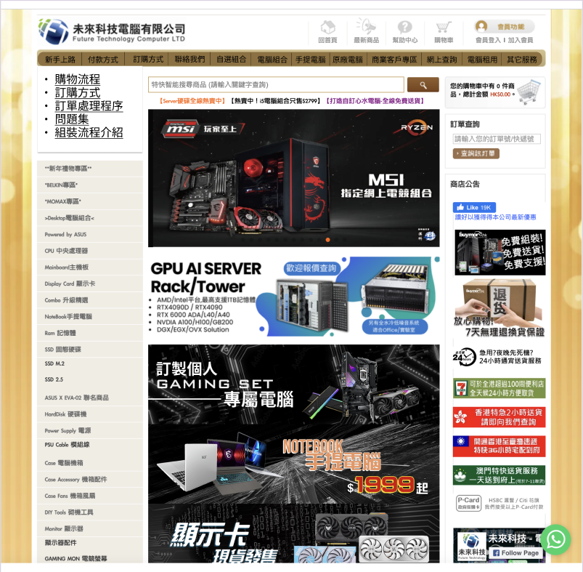

This screen is the home page. It can do a lot of things. In the old design, the "Getting Started(新手上路)" button in the bottom of home page. Customers may not find out the user guide. But the help and documentation are important. In the new design, it can see the "Getting Started" button in the Top of the bar. When clicking the "Getting Started" button will display a lot of help and documentation. Users would conveniently receive the guide. The user would more easily understand the flow. Also, the bar adds the other service button to navigate to the bottom to watch service.

**Original Design**



**After Redesign**

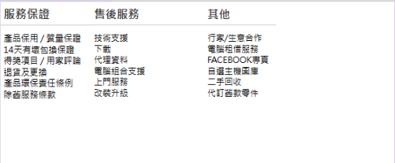

After Redesign, it just displays the service and others since the other function is repeated. The website should maintain an aesthetic and minimalist design. It reduces users' absorption of useless information.

**Original Design**

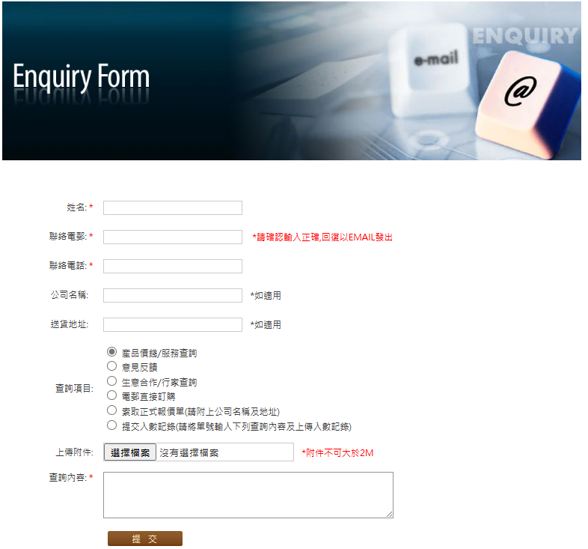

**After Redesign**

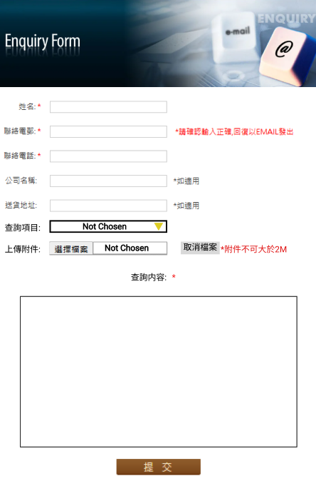

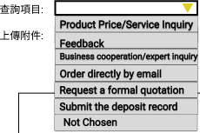

In the original design, the Query Item and Upload attachments did not have the cancel control for users to reset the Query Item choice to space and go back to no file chosen. The input box of Query Content is too small. All the lack needs to transform. After redesigning, the Query Item uses a dropdown menu

to make the user select one choice and add a “Not Chosen” choice provided to the customer. Therefore, users can choose to do nothing. Upload attachments have the same meaning. Giving the cancel file button to delete the file. Users would feel more flexible. To avoid the user entering all the information again since the user cannot go back to no file chosen, the user may refresh the page. Also, the Query Content should be larger. Users have more space to enter questions or feedback.

**Original Design**

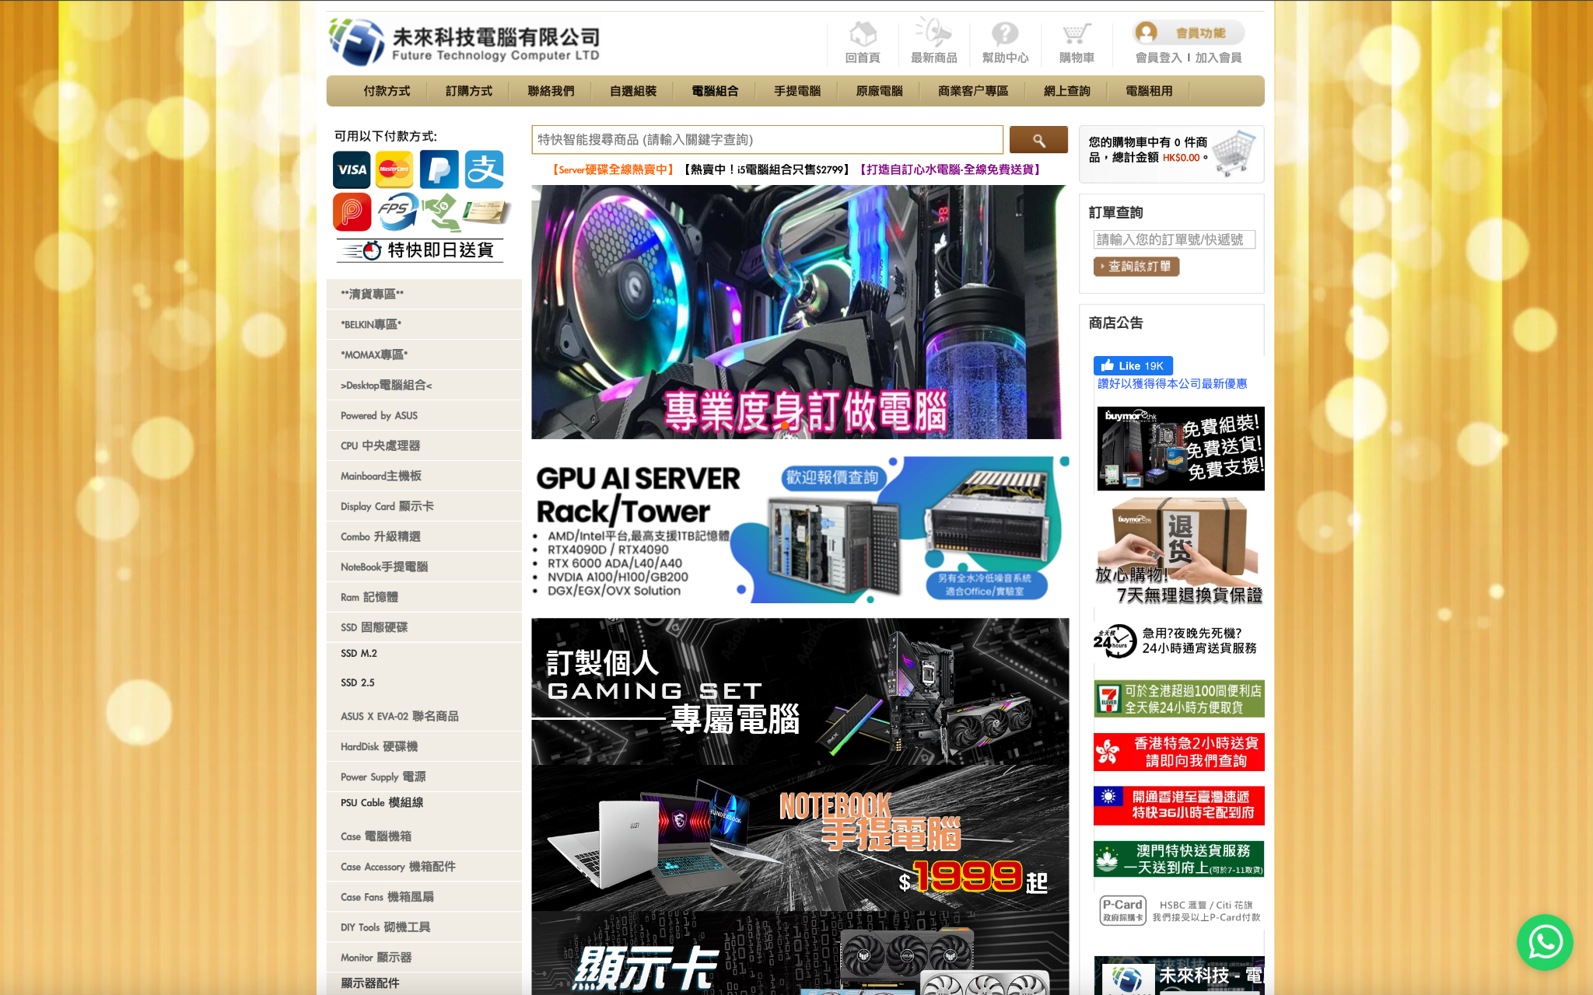

**After redesign**

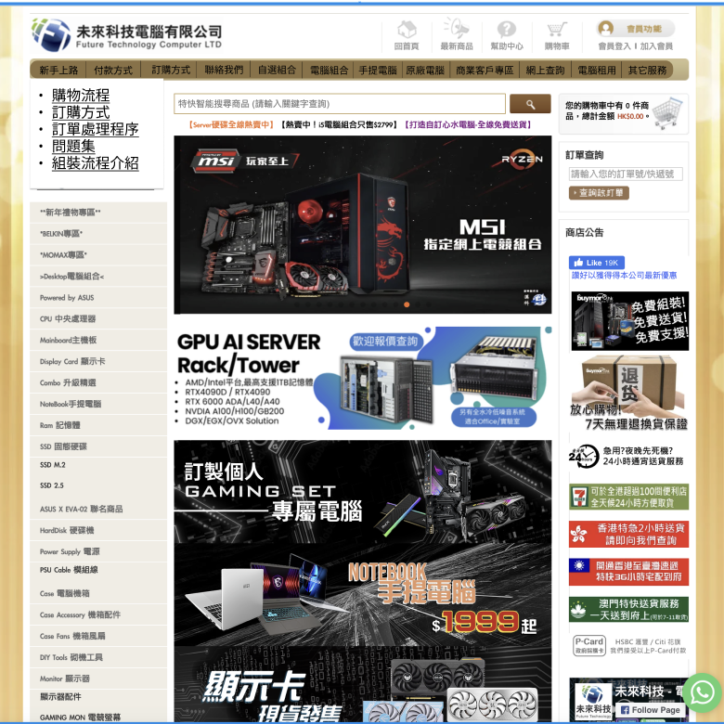

In the original design you can see the yellow color background on the left and right side. After redesigning, it should cut a lot of background since there is not any information for users to look at. At the same time, cutting the background would have more space. So, the content of any button, promotion or information can be bigger. It improves users' watching more focus and clear.

# 4.2 Prototype link

**Prototype Link:**

<https://www.figma.com/proto/BVsGSch4SLgScYdiBKOZNa/Lab1--Copy-?node-id=33-444&t=e0NwaJzdwwlkNS04-1>

**Dev Mode Link:**

<https://www.figma.com/design/BVsGSch4SLgScYdiBKOZNa/6002-Design?node-id=33-444&m=dev&t=e0NwaJzdwwlkNS04-1>

# 4.3 Demonstration

https://drive.google.com/file/d/1ljdVcO1hysVcYUssDuEDc-QvGSy3Jc2i/view?usp=sharing